Journaling Design Document

Table of Contents

Front end design 2

# Front end design

The initial setup starts with a home page. It consists of a heading, current time, and a text box for entering the current journal entry.

Each page refresh (i.e., each time the page loads), a new journal entry is shown.

A link to show the list of entries entered till now (for the current day) is present.

Upon entering the text, the entry is saved automatically.

Figure 1: First wireframe of website

# Backend design:

Currently there are two features supported by the system:

1. Saving a new entry.
2. Getting a list of previously entered entries.

When user opens the page and enters text into the textbox, a new entry is created.

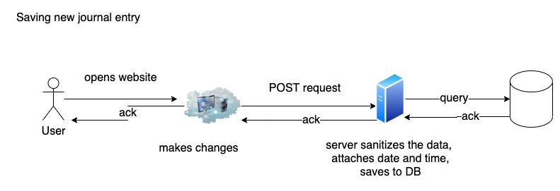

When the user clicks on the ‘See today’s entries’, the list of entered entries for that day is fetched from the server.

Please find the respective architecture design in the .drawio diagrams.